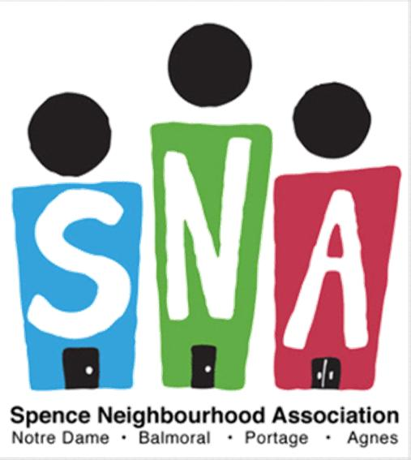
2019/2020 Youth Registration Form
MUST COMPLETE ALL FIELDS
Please return form to:​ Magnus Eliason Recreation Centre (MERC) – 430 Langside Street
NOTE: ​SNA Youth Program is for youth grades 7 - 12, ages 12-17. In order to receive transportation, all youth must submit a registration form signed by a parent/guardian
Registration for September 2019 - August 2020
Participant Information:
Name: _______________________________________________________________________
First Name Last Name

Age: ______________ Birthday: __________/__________/_________ Gender: __________
Month Day Year
Home Phone: ______________________ School: ____________________________________
Address: ______________________________________________________________________
House/Apartment # Street Postal Code
Canadian Citizen*: Country of Origin*: _________________________

Permanent Resident*: Permanent Resident Number*: ________________________

Indigenous/First Nation/Metis*:

*This information is for statistical and funding purposes only and it kept and used with the utmost confidentiality. For questions or concerns, please contact Carolina, Newcomer Youth Outreach Coordinator, at 204-8817974 or by email at newcomer@spenceneighbourhood.org

Allergies/Dietary Restrictions (Eg. Halal, Peanuts, Vegetarian Etc.) _________________________
Medical Conditions/Medications (Eg. Asthma, Epi-pen): ________________________________
Parent/Guardian/Caregiver Information:
Name: ___________________________________________________ Relation: _____________
First Name Last Name
Home Phone: _____________________________ Cell Phone: ___________________________
Name: ___________________________________________________ Relation: _____________
First Name Last Name
Home Phone: _____________________________ Cell Phone: ___________________________
Emergency Contact Information:
Name: ___________________________________________________ Relation: _____________

First Name Last Name
Home Phone: _____________________________ Cell Phone: ___________________________
Transportation: (Please check all that apply)
Participant requires safe ride home from program :

Note: Safe rides available for those living in and around the Spence Neighbourhood only (8:45PM)
Participant can be provided with bus tokens to get to and/or from program:

Participant is free to come and go from program:

Excursion Release:

By signing below you give permission for your son/daughter to participate in the “Youth Drop-In/Outreach” program. This includes regular programming which is from 6:30 PM - 9:00 PM from September to June as well as, special events (such as swimming, bowling, going to the movies, and other local outings). By signing below I give permission to the Spence Neighbourhood Association to take the above-mentioned participant on the above-mentioned outings (and others) as part of the Youth Drop-In/Outreach Program.
I understand that SNA is not responsible for any accidents that may occur or for youth who choose to leave programming without informing staff. Should these situations occur, appropriate action will be taken and parents/guardians will be contacted immediately.

Release and Photo Waiver:

In consideration of my/our child’s participation as outlined above, I/we agree to the following:
1. I/we agree to hold harmless The Spence Neighbourhood Association and third parties authorized by it (herein collectively referred to as the “SNA”) with respect to any and all losses, including any litigation expenses, legal fees, damages or costs that may be incurred by SNA in the event that my child pursues legal action against SNA arising from the use and publication by SNA for editorial, trade, advertising, promotion, social media or any other lawful purpose in any manner or medium, of any photographs, videotapes, motion pictures, audio recordings or any other recordings, images or likenesses of my child taken while he/she is participating in a media broadcast and/or being photographed as outlined above (herein referred to as the “Images”).
2. In addition, I/we agree not to sue SNA for any losses incurred personally by myself/ourselves arising from the use and publication by SNA for editorial, trade, advertising, promotion, social media or any other lawful purpose in any manner or medium, of any Images.
Please check below if you do not want your child’s photo to appear on the SNA website/newsletter, promotional materials, social media, or in West Central Times Community Newspaper. ( ) No Photos

Participant Name: _______________________________________________________________
Name of Parent/Guardian/Caregiver:________________________________________________
Date: _________________________________________________________________________
Parent/Guardian/Caregiver Signature: _______________________________________________

